SIM800C

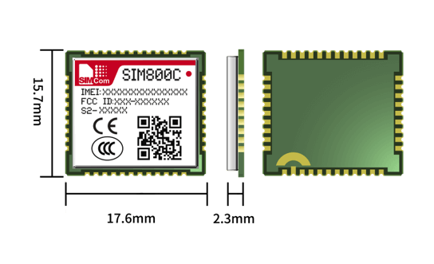

GSM/GPRS Module

The SIM800C is a Quad-Band GSM/GPRS module in a LCC type which supports GPRS up to 85.6kbps data transfer. It has strong extension capability with abundant interfaces including UART, USB2.0, GPIO etc. The module provides much flexibility and ease of integration for customer's applications.

Ge**neral features** feature

• Frequency Bands: 850/900/1800/1900MHz

• GPRS multi-slot class: 12/10

• Dimensions: 17.6*15.7*2.3mm

• Weight: 1.3±0.1g

• Supply voltage: 3.4 ~ 4.4V

• Operation temperature:-40℃ ~85℃

• Compliant GSM phase 2/2+: Class 4 (2W @ 850/900MHz)

• Compliant GSM phase 2/2+: Class 1 (1W @ 1800/1900MHz)

• Control via AT commands (3GPP TS 27.007, 27.005 & SIMCom enhanced AT Commands)

• Low power consumption

• GPRS mobile station class B

Product Advantages

●   Small size quad-band GSM/GPRS module

●   LCC form factor, easy for solder

●   Abundant software functions: DTMF, MMS, and MUX

●   Low Power consumption

●   Embedded TCP/UDP protocols

**Product Details**

**Soft Software features ware features**

• 0710 MUX protocol

• Embedded TCP/UDP protocol

• FTP/HTTP/POP3/SMTP

• MMS

• D TMF

• Jamming Detection

• Audio Record

• LBS*

• SSL/TLS*

• BT 3.0*

• TTS*

• EAT*

**IntInterfaceserfaces**

• Analog audio interface

• UART

• (U) SIM card (1.8V/3V)

• RTC

• ADC

• GPIO

• Antenna: GSM/BT\***f**

**Certificationsations**

•RoHS\REACH\CCC\CTA\SRRC\Mobile\Unicom\RCM\CE (RED)\GCF\BQB (Bluetooth)\TIM\Deutsche Telekom\ICASA\FCC\OCD (Anatel).

**Specifications for voice**

• Speech Codec Modes

– AMR/HR/FR/EFR

• Echo Arithmetic

– AEC/EES

**Specifications for SMS via GSM/GPRS**

• Point to point MO and MT

• SMS cell broadcast

• Text and PDU mode

|  |  |  |
| --- | --- | --- |
|  |  |  |